Preparation of Papers for JMEP

First Author, Second Author, Third Author

*Affiliations

**Abstract**— These instructions give you guidelines for preparing manuscripts for JMEP. Use this document as a template if you are using Microsoft Word. Otherwise, use this document as an instruction set. Define all symbols used in the abstract. Do not cite references in the abstract. Set all paragraph same as given here below the header; it sets the footnote at the bottom of this column.

**Keywords**— Maximum 8 and minimum 4 keywords are mandatory, but put in single line only. Use key words or phrases in alphabetical order, separated by commas.

# Introduction

# 

T

his document is a template for Microsoft Word versions 10.0 or later. If you are reading a paper version of this document, please download the electronic file from the template so you can use it to prepare your manuscript.

Please keep the template at 8.5” x 11”—do not set the template for A4 paper. Use italics for emphasis; do not underline. **Do not change the font sizes or line spacing to squeeze more text into a limited number of pages.**

JMEP staff will edit and complete the final formatting of your paper.

# Procedure for Manuscript Preperation

## Figures

All figures will be processed as images. You need to embed the images as JPEG/Tiff file inside the paper itself. Please don’t send the images as separate files.

## Copyright Form

A JMEP copyright form must accompany your final submission. You can get a .pdf or .doc version at Guidelines for Authors section. Authors are responsible for obtaining any security clearances.

# Sections

As demonstrated in this document, no numbering for sections is allowed. No paragraph or title is indented. Only the initial, introductory paragraph has a drop cap.

# Citations

Citation ranges should be formatted as follows: [1], [2], [3], [4]. When citing a section in a book, please give the relevant page numbers [2]. In sentences, refer simply to the reference number, as in [3]. At the beginning of a sentence use the author names instead of “Reference [3],” e.g., “Smith and Smith [3].”

# Equations

————————————————

Corresponding Author name, Mb.-01123456789

E-mail: author_name@mail.com

If you are using Word, use Microsoft Equation Editor. Number equations consecutively with equation numbers in parentheses flush with the right margin, as in (1). First, use the equation editor to create the equation. Then, select the “Equation” markup style. Press the tab key and write the equation number in parentheses. To make your equations more compact, you may use the solidus ( / ), the exp function, or appropriate exponents. Use parentheses to avoid ambiguities in denominators. Punctuate equations when they are part of a sentence, as in

 (1)

Please note that math equations might need to be reformatted from the original submission for page layout reasons. This includes the possibility that some in-line equations will be made display equations to create better flow in a paragraph. If display equations do not fit in the two-column format, they will also be reformatted. Authors are strongly encouraged to ensure that equations fit in the given column width.

# Helpful Hints

## Figures and Tables

**TABLE 1.** Units for Magentic Properties

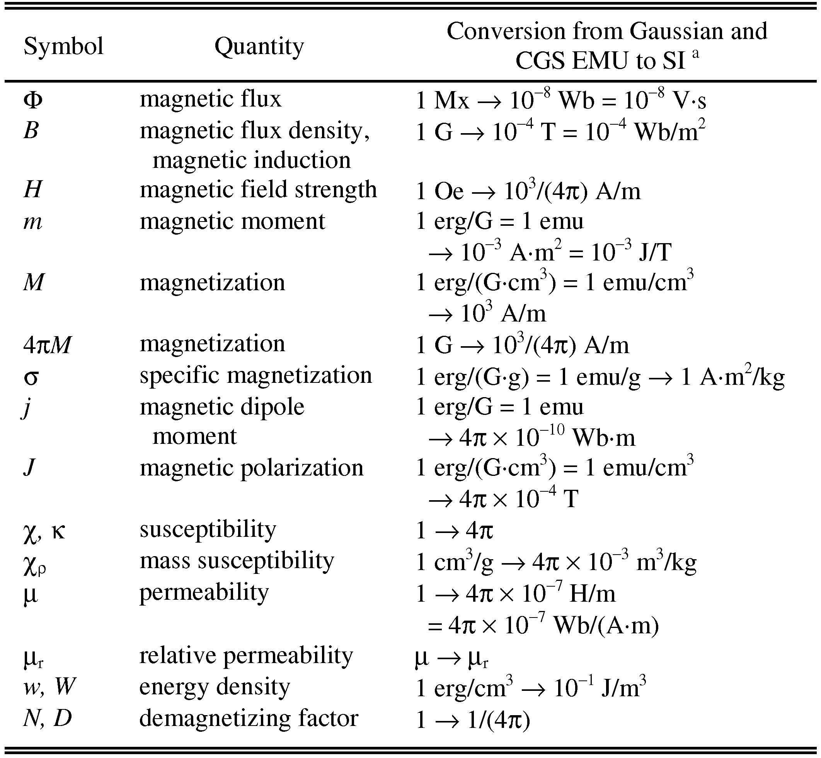

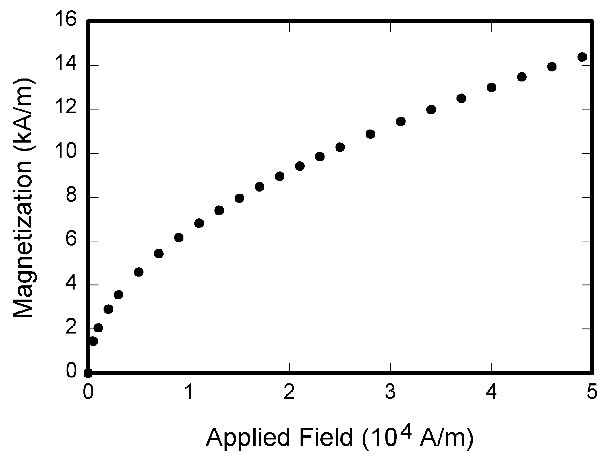

**Fig. 1.** It is good practice to briefly explain the significance of the figure in the caption.

# Conclusion

Although a conclusion may review the main points of the paper, do not replicate the abstract as the conclusion. A conclusion might elaborate on the importance of the work or suggest applications and extensions. Authors are strongly encouraged not to call out multiple figures or tables in the conclusion—these should be referenced in the body of the paper.

**Acknowledgment**

The authors wish to thank A, B, C. This work was supported in part by a grant from XYZ.

**References**

1. References should be styled and punctuated according to the following examples: journal article [1; journal supplement [2]; book [3]; edited book [4], thesis [5]; unpublished report [6]; published report [7]; proceedings [8], and patent [9].
2. Q.S. Liu, B. Roux, M.G. Velarde, Thermocapillary convection in two-layer systems, International Journal of Heat and Mass Transfer 41 (11) (1998) 1499-1511.
3. E.R.G. Eckert, H.H. Cho, Transition from transpiration to film cooling, International Journal of Heat and Mass Transfer 37 (suppl. 1) (1994) 3-8.
4. A. Bejan, Convection Heat Transfer, second ed., Wiley, New York, 1995, pp. 62-75.
5. M. Kaviany, Heat transfer in porous media, in: W.M. Rohsenow, J.P. Hartnett, Y.I. Cho (Eds.), Handbook of Heat Transfer, McGraw-Hill, New York, 1998, pp. 9.32-9.43.
6. W.-T. Yang, Two-phase swirl flow, PhD thesis, University of Illinois, Chicago, IL, 1997.
7. S.P. Vanka, Efficient computation of viscous internal flows, SBIR Phase-I Report, NAS3-25573, Propulsion Research Associates, Westmont, IL, August 1989.
8. J. Davids, D. Smith, Analysis of constant-velocity joints under high torque, HMSO, London, 1996, pp. 1-8. [viii] V.P. Carey, Modeling of microscale transport in multiphase systems, in: J.S. Lee (Ed.), Proceedings of the Eleventh Heat Transfer Conference, Taylor & Francis, Philadelphia, PA, 1998, pp. 23-40.
9. T. Burns, US Patent No. 358498, 1995.
10. M. Oguro, S. Imahiro, S. Saito, T. Nakashizuka, Mortality data for Japanese oak wilt disease and surrounding forest compositions, Mendeley Data, v1, 2015. http://dx.doi.org/10.17632/ xwj98nb39r.1